GRG 301 C – Fall 2013, The Natural Environment

Student Name ________________________ Lab Session_____________

Student EID _________________________ Date _____________

Score _______ out of 100

**Coastal Processes and Landforms**

**Exercise 1: Identification of Landforms** (1 point each)

Using Google Earth and the coordinates below as a starting point. Scan north-south and east-west to locate the coastal landforms. Write the location name next to the landform in the table below.

|  |  |  |
| --- | --- | --- |
| Location | Coastal Landform | Eroded or Deposited? |
| Galveston, TX, US  29° 18’ 13” N, 94° 47’ 55” W |  |  |
| Martha’s Vineyard, MA, US  41° 20’ 48.8” N, 70° 39’ 36.8” W |  |  |
| Porto Alegre, Brazil  30° 2'48.63"S, 51°14'27.91"W |  |  |
| Swanage, UK  50° 38’ 30” N, 1°55’ 23” W |  |  |
| Kilnsea, UK  53° 35’ 06”N, 0° 06’ 44” E |  |  |
| Ball’s Pyramid, Australia  31° 45’ 13.35” S, 159° 15’ 04” E |  |  |

**Exercise 2: Sea Defenses**

1. Identification (3 points each)

|  |  |
| --- | --- |
| Location | Sea Defense(s) |
| Sidmouth, UK  50° 40’ 91” N, 3° 14’ 16” |  |
| Urangan, Queensland, Australia |  |
| Humboldt Bay, California, USA  40° 43’ 10” N, 124° 14’ 33” W |  |
| Inbetween Schowen-Duiveland and Noord-Beveland, Netherlands  51° 46’ 46” N, 3°53’ 27” E |  |

1. Based on the discussion we’ve just had about ecology, name some of the benefits or potential pitfalls of sea defenses to intertidal species (8 points).

**Exercise 3: Spits** (3 points each)

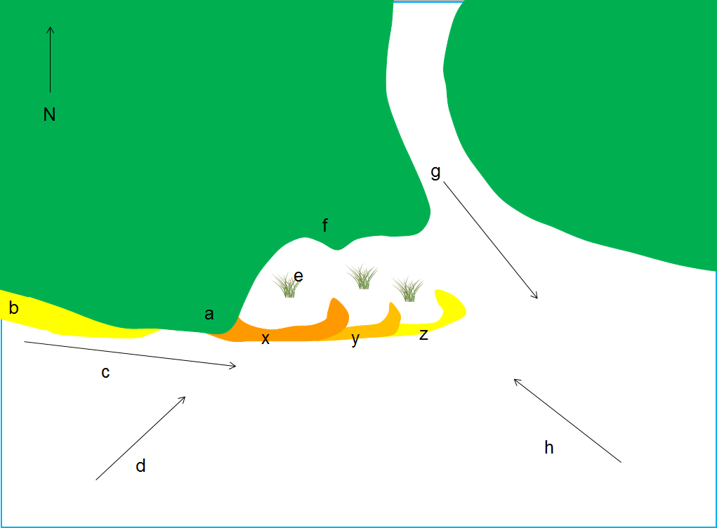

1. Match the following to their respective letter (2 points each)

|  |  |
| --- | --- |
| **Spit Feature / Factor Influencing Formation** | **Label** |
| Saltmarsh |  |
| Original Coastline |  |
| Short Term Change in Wind Direction |  |
| Fetch |  |
| Headland |  |
| Main River Flow |  |
| Longshore Drift |  |
| Beach |  |

1. The spit is made up of x, y and z. Which came first? Explain (5 points)

**Exercise 4 | Coastal Analyses of San Luis Pass - Texas**

[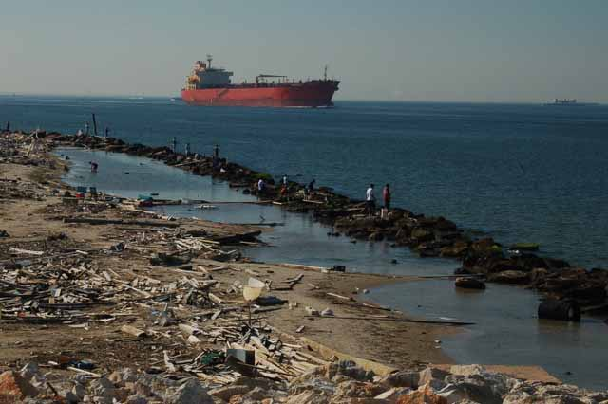](http://www.google.com/url?sa=i&rct=j&q=&esrc=s&frm=1&source=images&cd=&cad=rja&docid=f64XkduWrEUe7M&tbnid=DCY-te0faRS3mM:&ved=0CAUQjRw&url=http://thewanderingchick.com/txgalv.html&ei=n0s6UdTxFqei2QXx_IDADg&bvm=bv.43287494,d.aWM&psig=AFQjCNH-XvrEYIHUCF5zxx_6XGC3maIYjg&ust=1362861292625659)Most of the Texas coast (with the exception of Central Padre Island), beaches are protected by jetties. The new Brazos River delta has been undergoing erosion during the past 100 years. Prior to the development of deep inlets with long jetties necessary for commercial traffic (right) and damming the rivers that flowed to the Gulf for flood control and water supply during the 20th century, much of the Texas coast was stable or accreting (i.e., gaining sediment) and beach erosion was not a problem. Galveston Bay has always been Texas’ busiest port; however during the 1800’s a sand bar at its entrance prevented deep-drafted vessels from entering the bay.

In 1874, US Army engineers commenced work on two parallel jetties at the entrance to Galveston Bay. One jetty was connected to the eastern end of Galveston Island, while the other was extended from the western tip of the Bolivar Peninsula. By concentrating the bay’s outflow into a relatively narrow space, sediment exiting Galveston Bay is carried farther into the Gulf of Mexico, and a deep channel into the bay could be maintained.



*Bolívar Peninsula*

*Galveston Island*

*Follets Island*

Development of navigation inlets with long jetties such as the East Galveston Jetty has compartmentalized the coast and restricted longshore sediment transport along the coast, confining it to cells between major jettied inlets. Huge amounts of sand are trapped and stored adjacent to the jetties. Sand is also lost inward to flood tidal deltas and jetted offshore by ebb currents to depths where waves cannot return the sand to the beach. Since longshore sediment transport of the Texas Coast system carries sand west and south along the coast, sand moving southwest along the Bolivar Peninsula is now trapped at the East Galveston Jetty and can no longer nourish beaches on Galveston Island and Follets Island (above).

**Exercise 4** | **Directions:** Evaluate the coastal dynamics along a stretch of coastline on west Galveston Island, Texas. Points will be awarded based on the level of detail provided by your answers. To answer the following questions:

* Fly to the following coordinates: 29 12 53.81N, 94 55 01.28W.
* Set your eye altitude at around 2,450 ft.
* Activate the Historical Imagery feature (**View –> Historical Imagery**).

1. What were the conditions of this coastline like in 1954? Consider (3 points each)

a. the width between the shoreline and the coastline in meters (use the Ruler tool)

b. vegetation cover

c. land development

2. Proceed through images for the following years. When did development begin to occur along this stretch of coastline? (3 points)

3. Draw a sketch of the major man-made structures you can observe for this year. (5 points)

* Label the following features in your sketch: roads, vegetation, sand, coastline, and shoreline.
* Provide estimates for the following distances in your sketch: total length of coastline your sketch contains, distance from man-made structures to shoreline, distance between the coastline and the shoreline.

4. Compare the Jan-1995 and Feb-2004 images. What effect do the houses closest to the shoreline have on the way the shoreline might change naturally, if there were no development? Explain your answer. (6 points)

5. Look at the Sep-2005 images. What can you tell about the location of the shoreline and coastline at this time in comparison with the 1969 image? (Note: use the sketch you drew above as an aid to make these comparisons). (6 points)

6. What immediate effect did the storm surge during Hurricane Ike (Sept, 2008) appear to have in the deposition of sand along this stretch of coastline? (6 points)

7. What effect did Hurricane Ike have in the man-made structures along the coastline? Specifically, where do those homes closer to the sea now lie with respect to the shoreline and the coastline? 6 points)

8. The storm surge associated with Hurricane Ike had a long-term effect in the area’s coastal zone development. Notice the status of homes closer to the shoreline. Can you observe any attempt to stabilize this stretch of coast? Use the series of images between Sep-2008 and Oct-2012 to answer this question. (6 points)