Introduction to GPS Point and Track Collection
Goal: To learn the skills necessary to use a Global Positioning System in the field order to collect data for use within a GIS framework. Today we will focus on gathering data and utilizing the GPS for navigational purposes.
eTrex GPS from Garmin
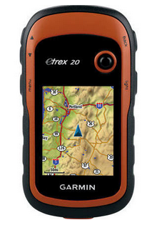
Menu Key
Zoom Keys
Power and Light Key
Thumb Stick
Back Key

Step 1: Clearing the memory
- Turn on your GPS unit by holding the ‘Power’ button
- Before starting, let’s delete all the waypoints and tracks stored in this GPS. Use the ‘Thumb Stick (TS), to navigate to the Setup menu and enter the setup menu. Navigate to the Reset menu and enter again using the TS. Select reset trip data and delete all the waypoints and clear current tracks using the TS.
- Now we should be able to start with a clear system.

Step 2: WAAS / EGNOS and Coordinate Systems
- First, we want to make sure that WAAS capability is turned on. There is not guarantee that you will get the signal, but if you do, it will increase your accuracy.
- Go in Setup again and then select System and select WAAS option and make sure it is ON.
- Hit the Back button and go to the Position Format tab and set your position format to what you prefer. I would suggest decimal degress (hddd.ddddd).
- Finally, scroll over to Map Datum and choose a datum you wish to use. I suggest NAD83.
- Return to the main menu.

Step 3: Collecting Data
Collecting points with a GPS is quite a simple process. Each type of GPS will differ somewhat from others, but overall the process will be similar. We will also use the tracking mode to record your track as you ‘rove’ around campus. We will be able to download the track as a polyline shapefile and the points as a point shapefile.
- Click on the Tracks icon. Go to record method, and select distance. After that, go to distance interval option and set the interval to 0.01km. By doing this, we have told the GPS to take a point based on distance, which is roughly every 10 meters. The points will create your track line.
- Return to the main menu.
- Go outside the building with a clear view of the sky (probably somewhere near the MLK statue). While standing still, find the icon Mark Waypoint and press the TS and click OK. This icon will appear once our GPS has located the satellites. Scroll to the notes section and type information on the attribute (i.e. “Starting Point”).
- Also write down the waypoint number and “Starting Point” in your notebook. When you’re in the field, it’s important to back-up your information in case the GPS goes wrong!
- Walk around campus and collect at least 10 points following the previous 2 steps. Make a note on what information we are identifying (i.e. statue, tree, animal, person. Whatever we’re interested in…). We’re going to use this information to make a map in ArcMap on Monday.
- Stay within campus. When we are finished, turn off the GPS and return to the computer lab.

Step 4: Downloading the GPS data
- Connect the USB cable from the GPS to the computer.
- Allow the computer a moment to recognize the device and load the driver
- Open the ‘Computer’ folder; double click on Garmin eTrex 20, then the Garmin folder, and finally the GPX folder.
- Copy all the contents of this folder to a new folder on your USB drive (n.b. all of your waypoint files will have a different name, according to the date, e.g. Waypoints_XX_Jul-15.gpx).
- After you have copied your files over, you can now disconnect the GPS from your computer.
- Zip the GPX folder on your USB drive, and upload the zipped folder to Canvas.

Keep hold of your USB, turn the GPS and connector back to me, and have a good weekend!

Step 5: Converting data to shapefiles
- Download your GPX folder from Canvas, and unzip in an accessible location. I’ve created a zipped folder for each of your groups under files. If you were not here on Friday, there is a dataset labelled Example_GPX on Canvas which you should use.
- Open ArcMap
- Open the search tool and search ‘gpx’
- Select the GPX to Features (Conversion) tool
- Navigate to your GPX file for the “Input GPX File”, and then save the Output Feature Class to your working folder as Waypoints.shp extension (n.b. if this does not work, delete the extension as ArcMap will automatically save the file as a *.shp). Give your computer a moment to make the conversion. There is a status tool bar in the bottom right corner which tells you how far along the process is. **Make sure you use your waypoints and not previous ones as there are multiple versions on the GPS’.

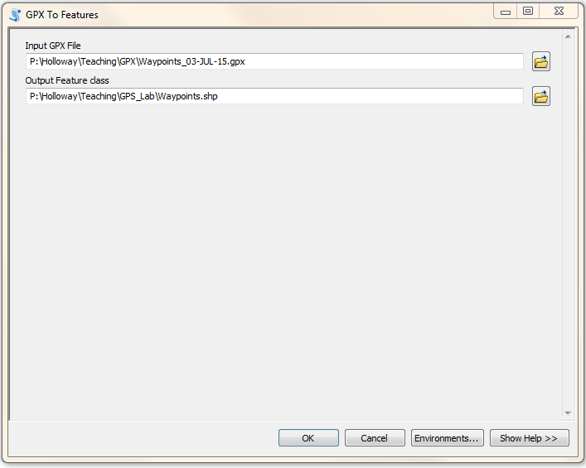
- Repeat the step for the GPS track log, which is found in the “Current” folder you also copied over. Save the output as “Tracklog.shp”.
- What format is your Tracklog.shp in? ArcMap should have imported this as a point shapefile, but we want it as a polyline.
- Open the Toolbox and navigate to Data Management Tools > Features > Points to Line
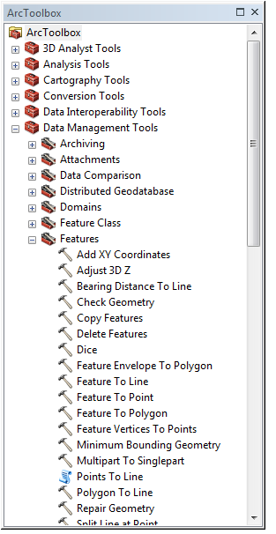
- Use your Tracklog.shp as the input and save your output in your working directory as Tracklog_Polyline.shp
Step 6: Adding Attributes
If you took the time to add attribute information as you walked around campus on Friday then most of this may not be necessary. However, make sure your comments are correct (i.e. check with your notes), and you may want to change your abbreviations to more detailed information. To do this, start at step 4.
- Find your notebook or notes from Friday with the information on it
- Open the attribute table for your waypoint dataset
- Your data should look like this: 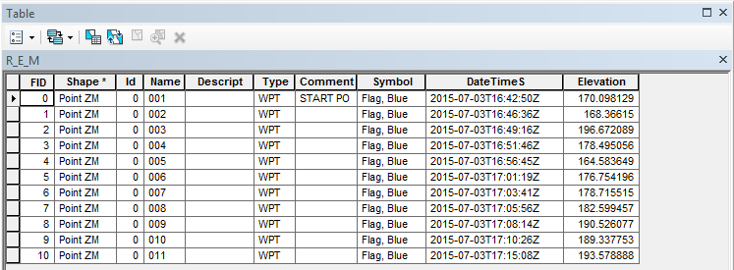
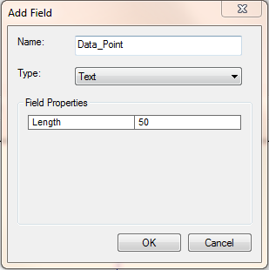
- Under table options (first image to the left), click on Add Field, and create a field name of Data_Point, and make sure the field is a Text file:

- Navigate to the Editor Toolbar. If yours is not showing, right click on the gray space to the right of the Help menu, and you will get a dropdown menu. Make sure Editor is ticked.
- Click the Editor dropdown menu, and click Start Editing. Make sure you are editing the folder and dataset you are working on (but as you’ve saved everything in your working directory this shouldn’t be an issue).
- Under your column of Data_Point, you should be able to type information into this.
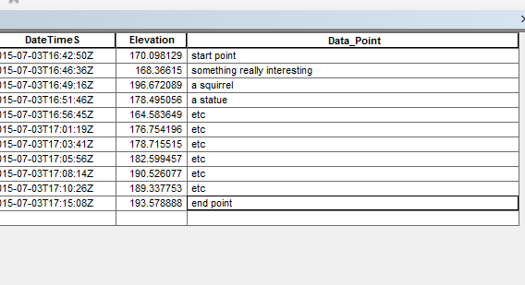

- Click on the Editor dropdown, and click save edits.
- Re-click on the Editor dropdown and click stop edits. Now you won’t be able to edit your attribute table. Check that this worked, and you have information in your attribute table.
Step 7: Exporting to Excel
For many statistical reasons, we may want to export our data to Excel. There are a couple of ways to do this. The first way is as follows:
- Open the attribute table, and select all the objects (hint: Cntl + A). Right click on the gray area to the left of the FID column, and press Copy Selected.
- Open Excel, and in A1 paste the information.
The second way is as follows:
- Open a new worksheet
- Navigate to open a new document. Make sure “All files (*.*)” is selected.
- Navigate to your working directory and select the file with the *.dbf extension.
- You may have to resize your columns, but the information should be the same. Check this is the case.
Step 8: Making Maps
I want you to submit 2 maps, so go back to ArcMap and complete the following.
- Make a map with a background image (Add Data > Basemap) and your Waypoints.shp. Use your label field to label the features in the map
- Make another map with your Tracklog_Line.shp and a background image
If we right click on the layer file, and go to Properties, we can change the Symbology of the points and lines, and use advanced symbols. Under Symbology > Categories, you can navigate to Comment or Data_Point as the Value Field, select Add All Values and then you can create unique symbols for each of your data points.
Follow good cartographic practices (i.e. scale bar or text, north arrow), and make sure your make is clear and easily readable.
To export your maps, click on File > Export Map. Save as a *.png or *.jpg, and submit through Canvas.
Worth 20 points towards your portfolio.

Example Dataset, copy attributes into new field as follows
Attribute Correct Name
START Start Point
COP Police Car
ZIP Zip Car
GOLF Golf Cart
MBIKE Motorbike
CLAMP Clamped Car
BIKE Bicycle
HORSE Horse
CLEAN Cleaning Cart
DIG Digger
BUS Bus

