Landscape Ecology Name:
GRG 335N, Spring 2015
In-Class Project 6: Quantifying Landscapes Using Fragstats
In this computer-based project, we will be analyzing land cover change in a savanna landscape. You will be given thematic land cover maps of Botswana obtained from MODIS product MCD12Q1. We will perform quantitative analysis using a free software package designed for pattern metric analysis, FRAGSTATS. In this project, we will
- Download FRAGSTATS and the data
- Examine the impact of changing grain size on the analysis
- Analyze landscape change from 2001-2011
- Complete the write up
The due date for the write up is 5:00PM on Thursday, March 26th. It should be typed neatly and include the results. Please submit to Canvas.
Part 1 – Downloading FRAGSTATS and the data
**IMPORTANT** Be sure you are using a Windows-based PC or laptop. The software will NOT work on a Mac. This software is not available on University computers unfortunately, but we will get through all the analysis in class.
- Go to http://www.umass.edu/landeco/research/fragstats/downloads/fragstats_downloads.html and download the current version, 4.2. Look for a link called fragstats4.2.zip. Follow the direction on the website under the section called “Installing FRAGSTATS”.
- Download the FRAGSTATS documentation that explains each metric (*.pdf). You will need this for the write up. http://www.umass.edu/landeco/research/fragstats/documents/fragstats.help.4.2.pdf
- Go to Canvas > Files > Fragstats Practical and download the 2001 and 2011 data. Note that there is one raster file for 2001, and two raster files for 2011. The two 2011 files are of different grain size: 500m and 2000m. They are the same extent. Save the data in a new folder that you can locate easily.

- The data contain 9 land cover classes with the following ID numbers:
- Water
- Forest
- Shrubland
- Savanna
- Grassland
- Permanent Wetlands
- Agriculture
- Urban
- Barren
Part 2 – Examine the impact of changing grain size on the analysis
- Open FRAGSTATS
- Click on New.
- Click on Add Layer and select GeoTIFF grid (*.tif) as the data type selection
- Select the lc2011_500m.tif file for the fine scale data. Once selected, the filename should appear under Input Layers > Batch Management > Layers
- Under Input Layers > Common tables > Select Use fixed depth. Enter 50. This specifies our definition of an edge. The Edge Depth parameter is used to specific how far into a patch the edge effects are expected to be an influence. In this instance, we use 50 meters.
- Under Analysis parameters > Sampling Strategy > Select Class Metrics and Landscape Metrics. Leave the default on 8 neighbor rule.
- Under Analysis parameters, select Automatically save results. Save results to a folder destination of your choice (REMEMBER WHERE THIS IS!). FRAGSTATS will create a *.class and *.land file that are easily imported into Excel
- Select Class Metrics 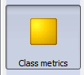 and select the following metrics:
  - AREA: Total Area (TA), Percentage of Landscape (PLAND), Total Edge (TE)
  - CORE AREA: Total Core Area (TCA) and Core Area Percent of Landscape (CPLAND)
- Select Landscape Metrics 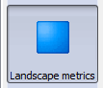 and select the following metrics:
  - AGGREGATION: Number of Patches (NP), Patch Density (PD) and Contagion (CONTAG)
  - DIVERSITY: Shannon’s Diversity Index (SHDI) and Shannon’s Evenness Index (SHEI)
- Select one additional Metric of your choice. Be prepared to defend the ecological significance of this metric in the write-up. Please DO NOT select any patch metrics. There are 72551 patches in this study area and it will take a long time to process. You are welcome to try it after class!
- Select Run 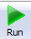 and then select Proceed.
- View the Results 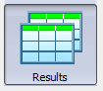 (Class and Landscape) in order to ensure that the program executed the calculations. There will be several rows of results in the Class tab (one row for each land use class), but only one row in the Landscape tab because we are calculating metrics on only one landscape.
- Save the project in the same folder by clicking on Save As
- Open the results in Excel. FRAGSTATS creates a *.class and a *.land file that store the results. To import into Excel, open Excel, select File > Open and navigate to these files. They are comma delimited files.
- Add a column call Land Cover in which you label the 9 class names. This will help you with interpretation
- Save these Excel files in *.xlsx format. You can save them in two separate files or you can combine them into one file.
- Repeat steps 5-20 for the 2km resolution data. Insert the 2km data into the same Excel Worksheet below the 500m data to facilitate comparison. Your Excel sheet should look something like this (different values of course). If you have a better format, feel free to use it.

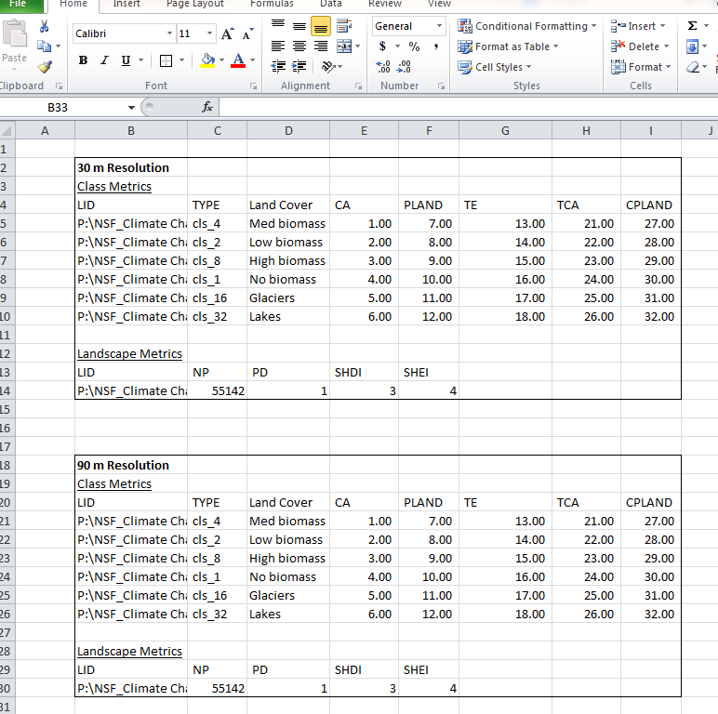

Part 3 - Analyze landscape change from 2001-2011
- Reopen FRAGSTATS
- Click on New
- Input the 2001 layer (as a GeoTIFF)
- Select fixed depth as 50 again
- Under Analysis parameters > Sampling Strategy > Select Class Metrics and Landscape Metrics
- Under Analysis parameters, select Automatically save results and save to the same folder destination as results2001to2011.
- Choose a 8 neighbor neighborhood under Analysis parameters

- We are going to use the following Patch Metrics, however due to the processing power needed for this, I have provided these results on Canvas:
  - AREA: Patch Area (AREA)
  - SHAPE: Perimeter-Area Ratio (PARA)
  - AGGREGATION: Euclidean Nearest-Neighbor Distance (ENN)
- Select Class Metrics and select the following metrics:
  - AREA: Total Area (TA) and Percentage of Landscape (PLAND)
  - Select 2-3 addition metrics of your choice. You may want to consider the questions listed below before making your decision. Consult the FRAGSTATS manual to aid in your selection
- Select Landscape Metrics and select the following metrics:
  - AGGREGATION: Number of Patch (NP) and Patch Density (PD)
  - DIVERSITY: Shannon’s Diversity Index (SHDI) and Shannon’s Evenness Index (SHEI)
  - Select 2 addition metrics of your choice. You may want to consider the questions listed below before making your decision. Consult the FRAGSTATS manual to aid in your selection
- Select Run and Select Proceed.
- Save the project by clicking Save As > your folder destination
- Open the results in Excel.
- Add a Land Cover column
- Save this in an *.xlsx format.
- Repeat steps 22-36 for the 2011 image. Insert the 2011 results below the 2001 results
- Email these results to your group so that everyone can complete the write up.

Part 4 – Complete the Write Up
- By comparing two grain sizes 500m and 2000m, what basic scale-related principle does this demonstrate?
- One major difference between the 500m and 2000m resolution data is the TE. Why is this so dramatically different?
- Identify 3 other major differences and explain the source of those differences.
- If you were asked to map the extent of savannas in Botswana for an environmental company, which resolution would you use? Why?
- If you could increase the map extent beyond the national boundaries and keep the resolution the same, how might the metrics change?
- Do any of the metrics not change between 2001 and 2011?
- Bush encroachment is the process of woody vegetation changing savannas into shrublands. What was the total savanna area in 2001? In 2011? What was the shrubland area in 2001? In 2011? Based on only these statistics, is bush encroachment occurring?
- What cover type is the largest patch in 2001 and in 2011?
- What other changes in pattern do your results show?
- Climate change can explain land cover change, but proving causation can be difficult. What land cover changes do your results suggest that may NOT be related to climate change? Explain what process(es) may be causing those changes.
- What is your interpretation of SHDI and SHEI?
- Defend your selection of additional metrics and explain why they area ecologically meaningful. Be sure to report your results
- Include your comparison tables in the final write up.
Directions for the Final Write Up
There should be two sections in your final write up that include answers to the questions and the results. Be as specific as you can when answering the questions and use numerical results to support your answers. Type your answers neatly and identify the answers to each question using the corresponding letter. You can insert you Excel results using screenshot or snip, but make sure they are labelled.

