Landscape Ecology, GRG 335N, Spring 2015 Name:
Exercise 5: Landscape Metrics
The idea behind this exercise is to get some firsthand experience at calculating some of the landscape metrics we learnt about in class.
Overall Statistics
Calculate the following statistics for the below landscape / study area.
Area:
Perimeter:
Perimeter to Area Ration (P/A):
Shape:
Patch-Based Metrics
Patches are a common feature when identifying landscape structure. A patch can be identified in two ways. Firstly a patch may consist of adjacent cells in only four directions (rook’s case of connectivity), or it can consist of adjacent cell from eight directions (Queen’s case of connectivity). How many patches are there under each connectivity classification, and what is the area of the largest forest patch in Figure 1 when we use rook’s connectivity, and when we use Queen’s case?
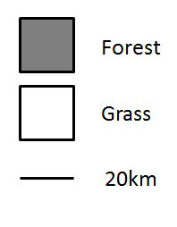
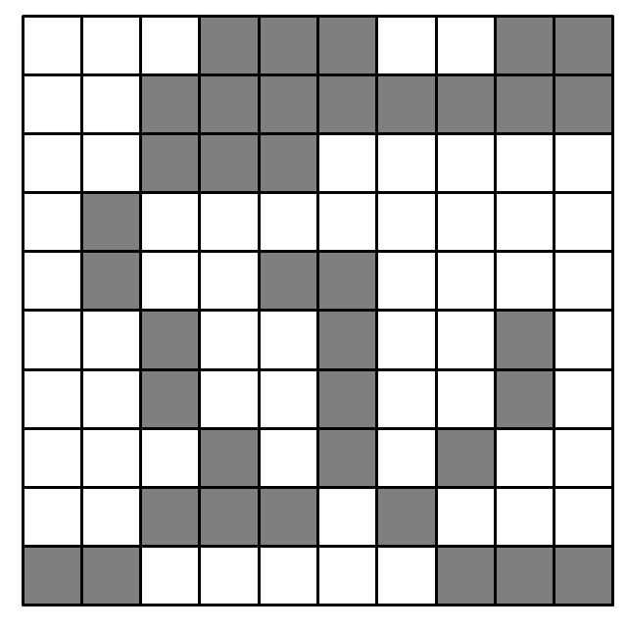

How many patches under rook’s?

Area of largest patch (rook’s case)

How many patches under Queen’s?

Area of largest patch (Queen’s case)
Using the following equation, what is the relative size of largest forest patch using rook’s case?
$$RS= \frac{Largest patch of cover type i}{(p_{i} ×total study area)}$$

Where p_{i} = proportion of landscape in cover type i

Connectivity
What is the distance between these two patches?
Calculate the distance using the centroids (rough estimate for uneven patch will suffice), closest edge, farthest edge.
Centroid distance:
Closest edge distance:
Farthest edge distance:
Give one advantage and one disadvantage of using each method:

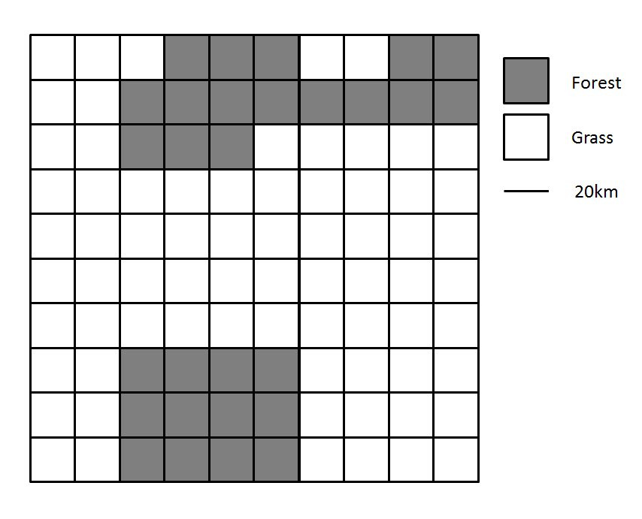
Describe what impact the introduction of the river (below) has had on the distances calculated above.

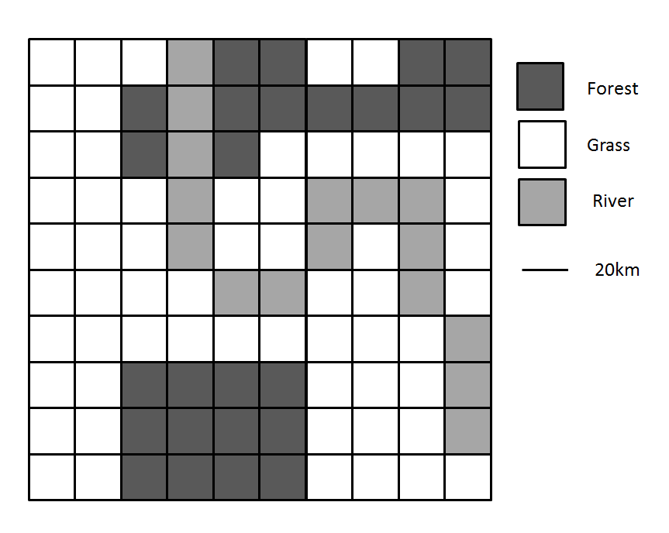
What is the richness of this landscape?
3
The above landscape is a subsection of a landscape which also has urban cover, shrubland, agriculture land and bare rock. Using the following equation, what is the relative richness of our above grid?
$R= \frac{s}{s_{max}}$ $×$ 100

Where s is richness and s_{max} is the number of possible cover types
42.86
Evenness is a measure of diversity, and refers to how evenly the proportions of LC types are distributed, and is standardized by the number of LC types. Using the following equation, calculate the evenness of the above landscape.
$$H=\frac{-\sum_{i=1}^{s}{\left(p_{i}\right)}ln\left(p_{i}\right)}{ln⁡(s)}$$

where pi is the proportion of landscape occupied by cover type i, s is the number of cover types present.
ln is a natural logarithm.
ln (forest) = -1.386
ln (grass) = -0.528
ln (river) = -1.832
ln (richness) = 1.099
p(forest)*ln(forest) = -0.3465
p(grass)*ln(grass) =-0.31152
p(river)*ln(river)= -0.29312
∑ (p_{i}) = 0.95114
H = 0.8655
Is this landscape configuration even?

So far, all of these metrics have been aspatial. Quickly summarize what this means.

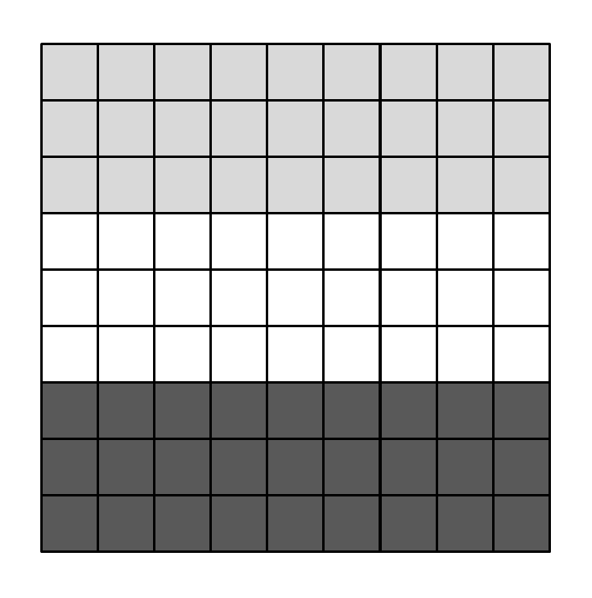
Contagion is a spatial metric, and distinguishes between clumped or dissected landscapes. This is calculated from the probability that two adjacent pixels will be from the same land cover class. We will compare the adjacencies with cells of the same value with cells of a different value. In the matrix on the right, write the number of times a cell shares a side with a cell of a cover type.

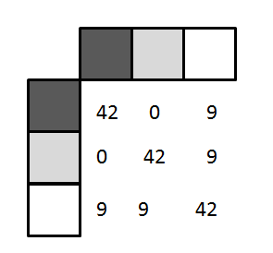

BB BG
WW BW
GG GW
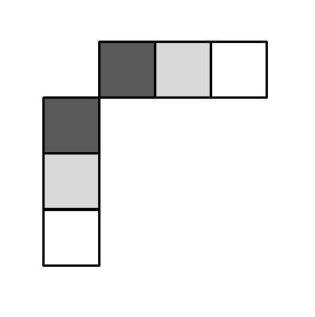
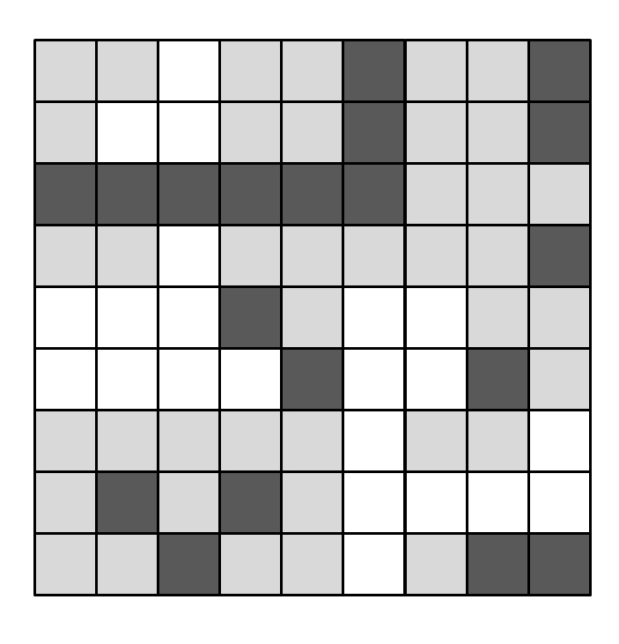

What is the combination of land covers that have the highest number of adjacencies?

What is the combination of land covers that have the lowest number of adjacencies?

The equation for contagion is:

$$C= \frac{1+ \sum_{i=1}^{s}{\sum_{j=1}^{s}{\left(P_{ij}\right)}ln⁡(P_{ij})}}{2 ln⁡(s)}$$
where P_{ij} is the probability that 2 randomly chosen adjacent pixels belong to cover types i and j respectively, and s is the number of cover types in the landscape. When we reach this point, we’ll reconvene as a group and discuss the power of Fragstats.

